**CHAPTER 5**

**SNAPSHOTS**



**Figure 5.1 Homepage of the Application**

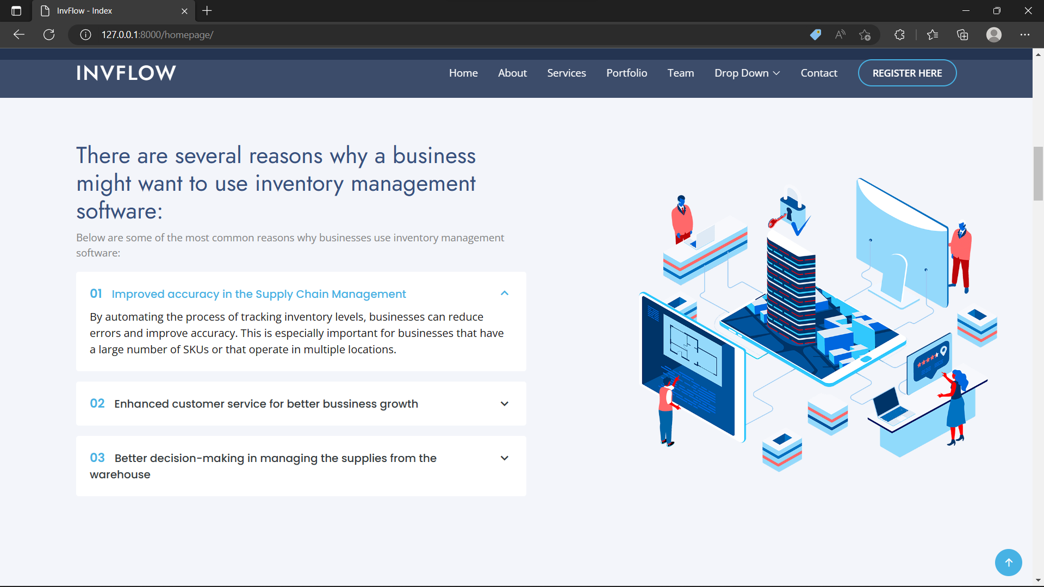

**Figure 5.2 Introduction Section of Application**

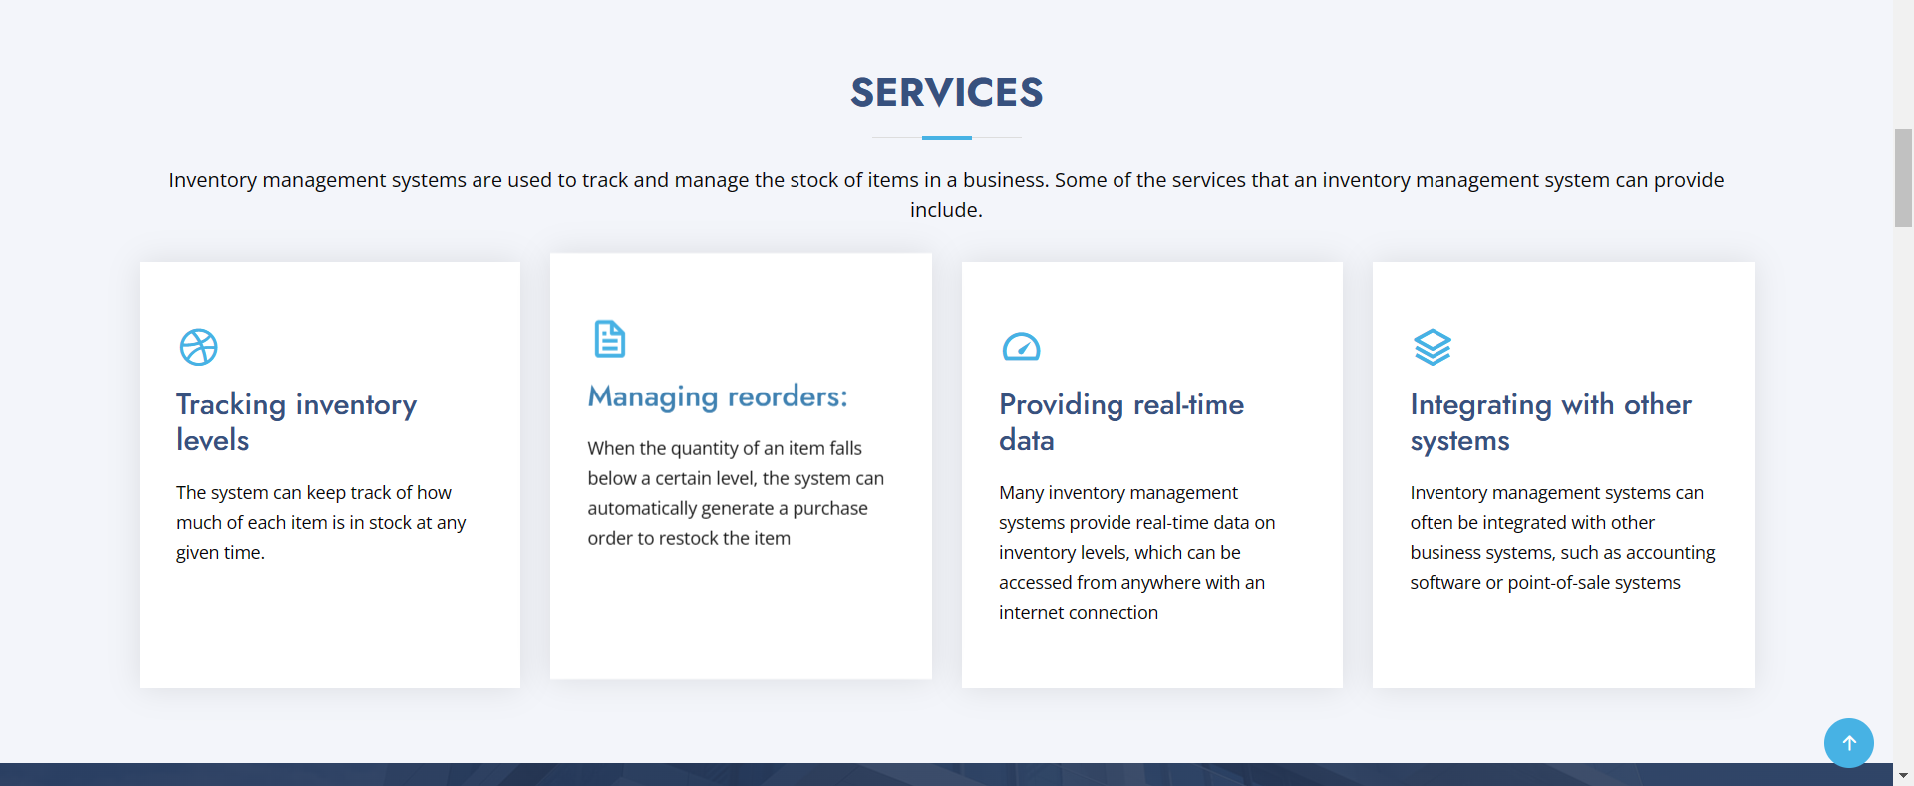

**Figure 5.3 Services section of the Application**

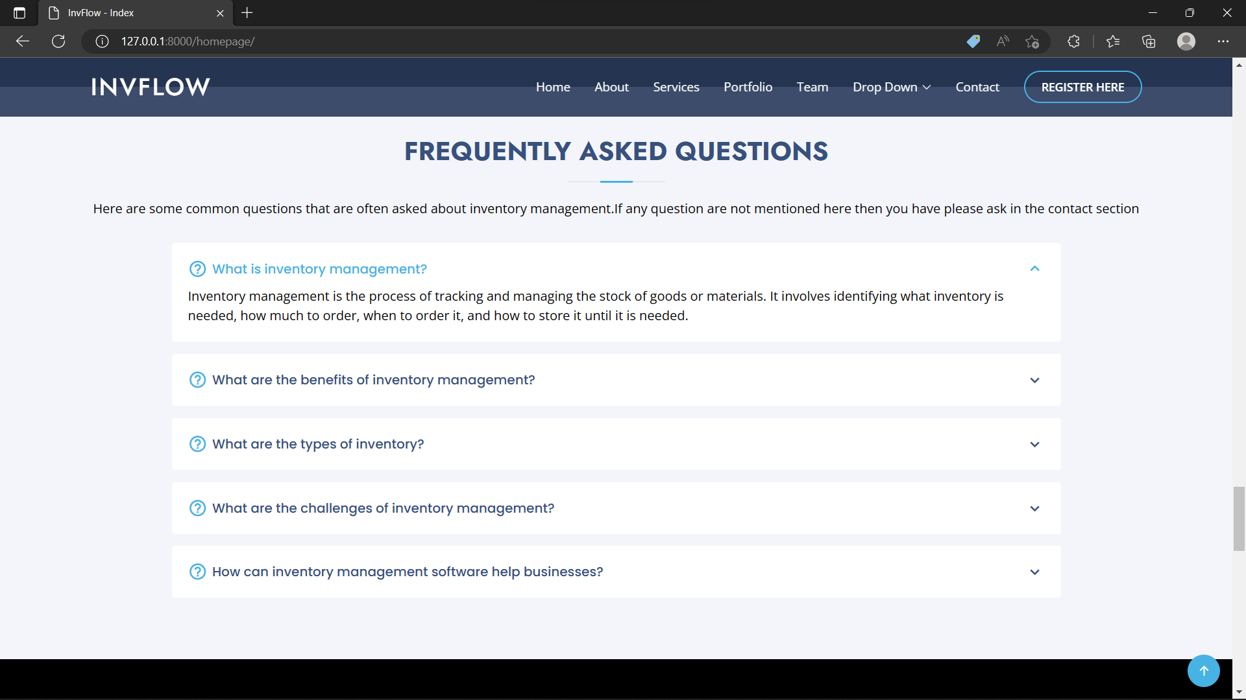

**Figure 5.4 Frequently Asked Questions Section of the Application**

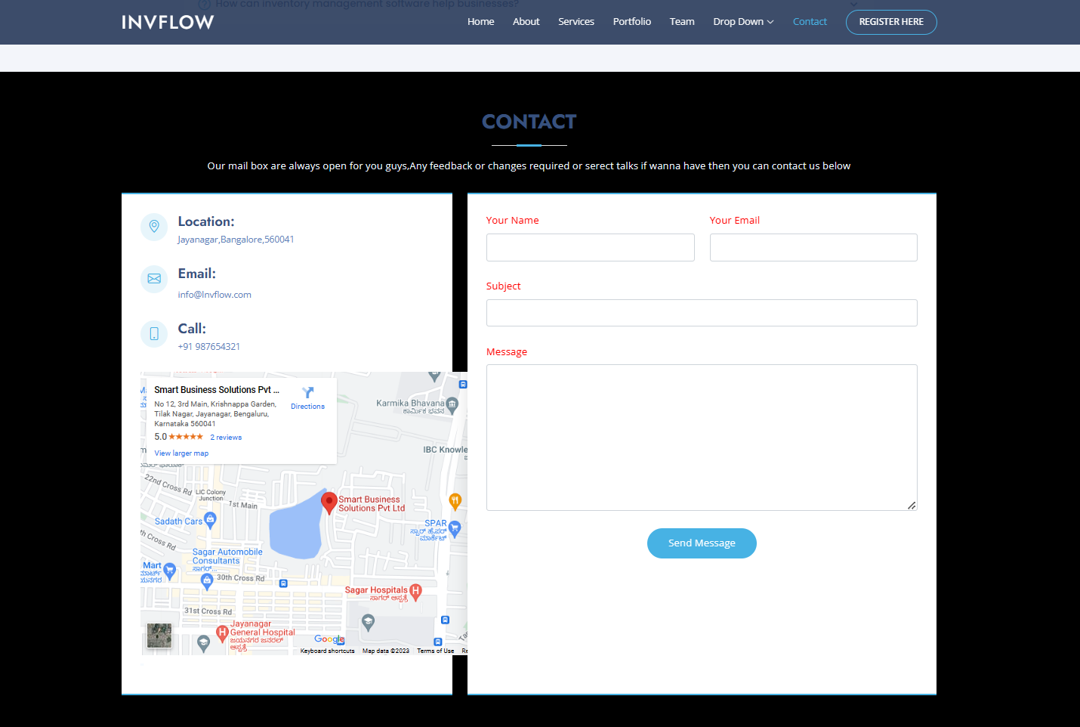

**Figure 5.5 Contact Section of the Application**

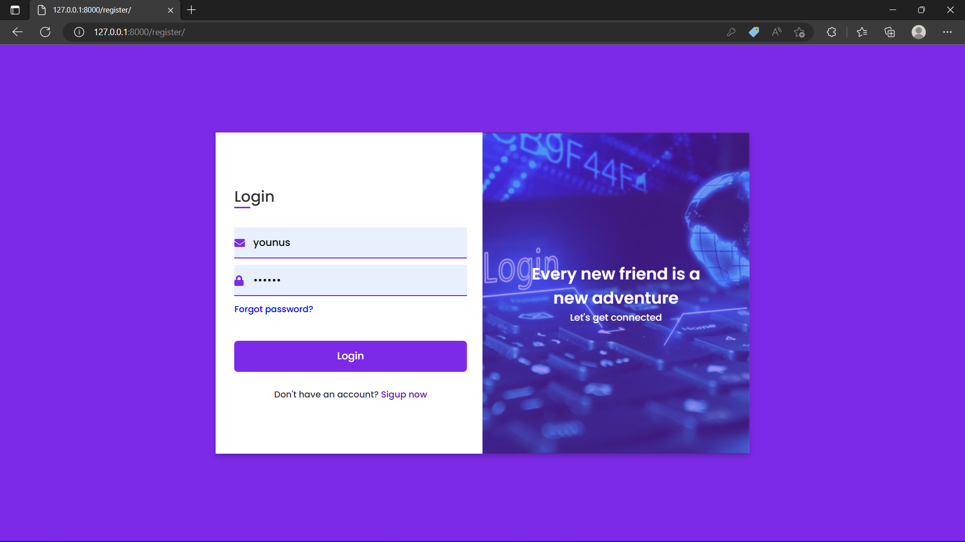

**Figure 5.6 Login Page of the Application**

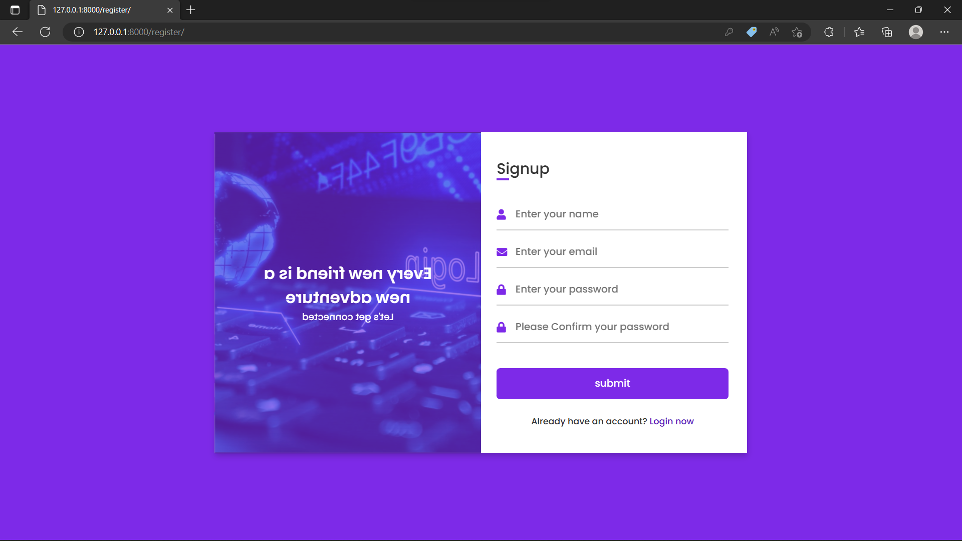

**Figure 5.7 Signup Page for the Application**

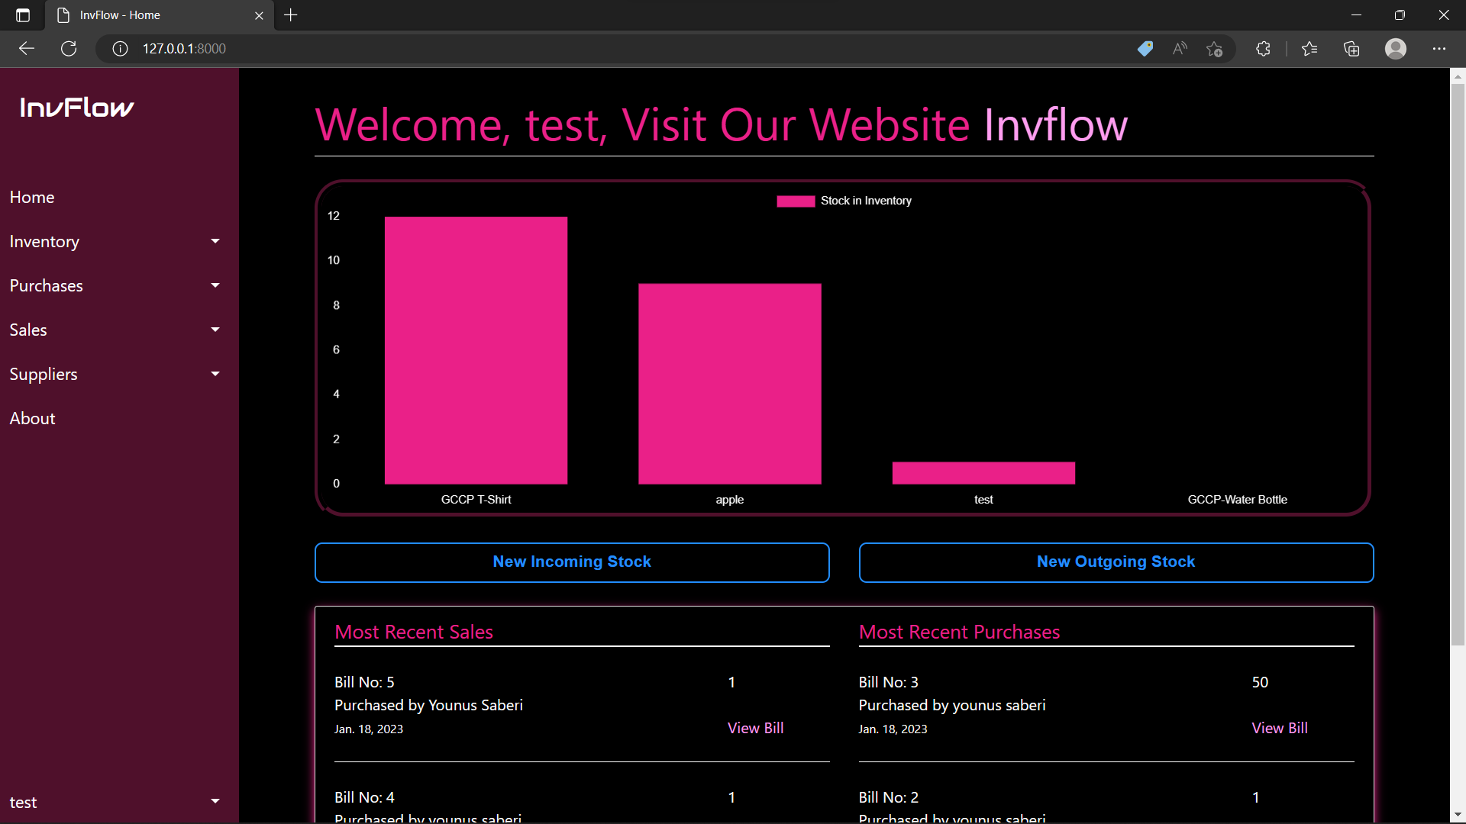

**Figure 5.8 Dashboard of the Application**

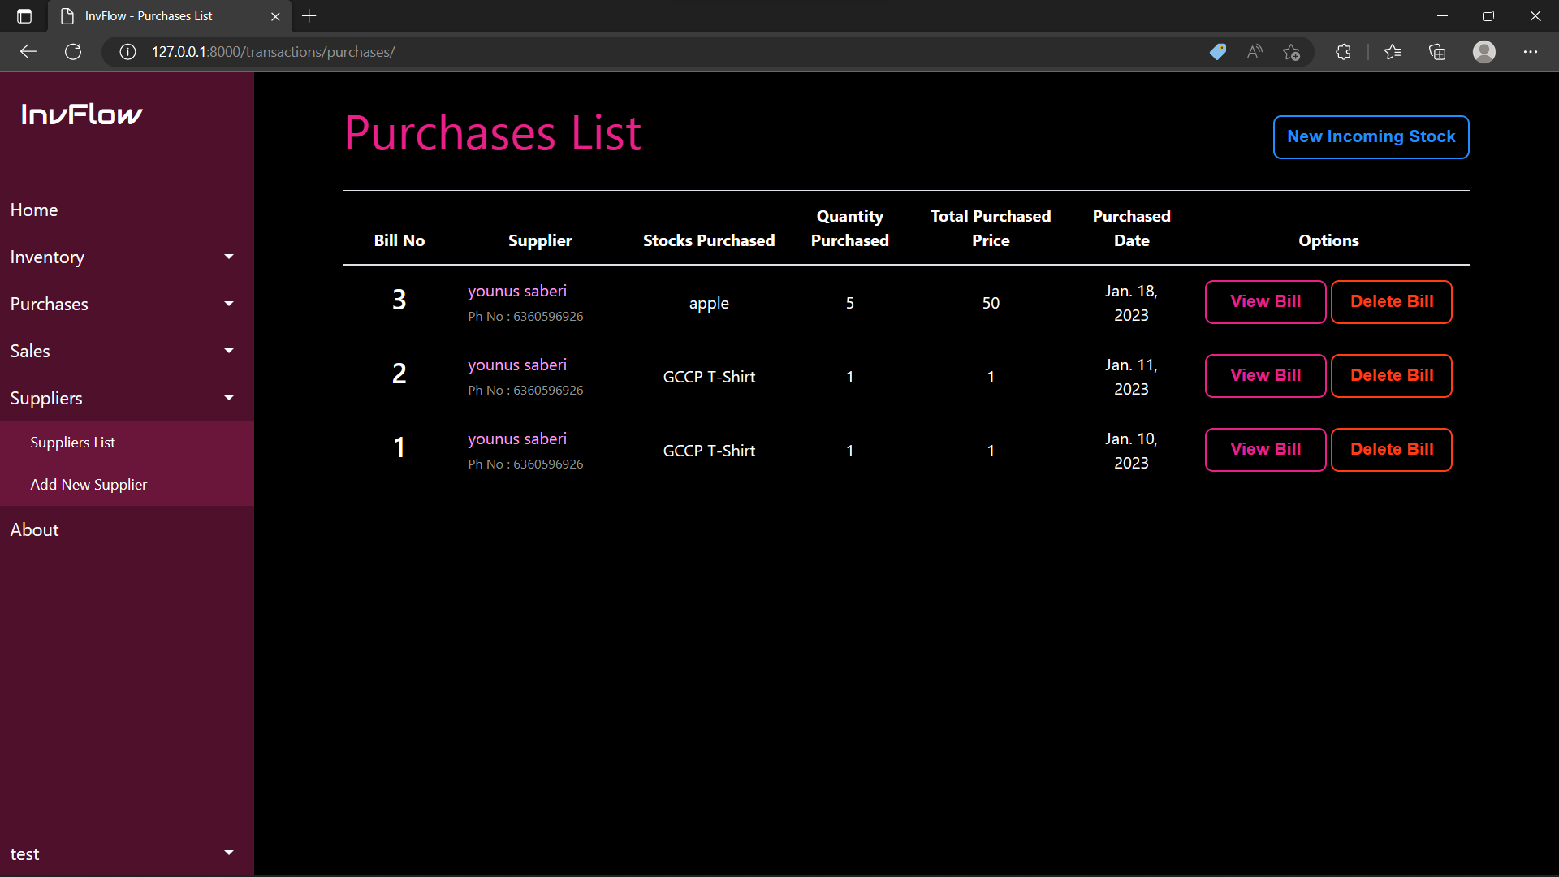

**Figure 5.9 Purchase List of the Stocks**

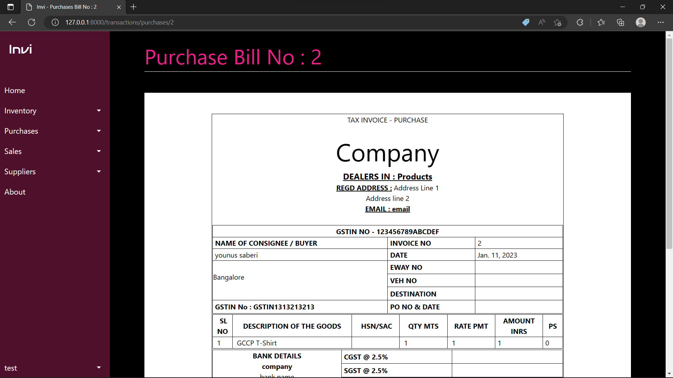

**Figure 5.10 Bill Generation After Each Purchase**